**MOBILE COMPUTING - 20XW61**

**ASSIGNMENT PRESENTATION**

20PW15

Karthik K M

**CDMA**

CDMA (Code Division Multiple Access) is a wireless communication technique that allows multiple users to share the same frequency band by assigning a unique code to each user.

In CDMA, the rate of the data signal is denoted by D, and each bit is broken down into k chips. The chips are a user-specific fixed pattern, and the chip data rate of the new channel is kD.

For example, if k = 6 and the code is a sequence of 1s and -1s, for a '1' bit, User A sends the code as a chip pattern <c1, c2, c3, c4, c5, c6>, and for a '0' bit, User A sends the complement of the code <-c1, -c2, -c3, -c4, -c5, -c6>. The receiver knows the sender's code and performs an electronic decode function. If the received chip pattern is <d1, d2, d3, d4, d5, d6> and the sender's code is <c1, c2, c3, c4, c5, c6>, then the decoded data is given by: Sud = d1*c1 + d2*c2 + d*c3 + d4*c4 + d5*c5 + d6*c6 where S is the sum of the products of each received chip and the corresponding code chip. If S is positive, then the received bit is a '1', and if S is negative, then the received bit is a '0'.

Note that the number of chips per bit (k) and the code sequence can vary depending on the implementation.

**CDMA Example**

User A has a code of <1, -1, -1, 1, -1, 1>. To send a '1' bit, User A transmits the chip pattern <1, -1, -1, 1, -1, 1>, and to send a '0' bit, User A transmits the complement of the code, which is <-1, 1, 1, -1, 1, -1>.

User B has a code of <1, 1, -1, -1, 1, 1>. To send a '1' bit, User B transmits the chip pattern <1, 1, -1, -1, 1, 1>.

The receiver is received with User A's code. To decode the received signal, the receiver performs the dot product of the received chip pattern with User A's code:

(A's code) x (received chip pattern)

If the result is positive, the received bit is a '1', and if the result is negative, the received bit is a '0'. If the dot product is zero, then the signal is an unwanted interference and can be ignored.

For example, if the received chip pattern is <1, -1, -1, -1, 1, -1>, then the dot product with User A's code is:

<1, -1, -1, 1, -1, 1> x <1, -1, -1, -1, 1, -1> = 6

Therefore, the received bit is a '1'.

If the received chip pattern is <-1, 1, 1, -1, -1, 1>, then the dot product with User A's code is:

<1, -1, -1, 1, -1, 1> x <-1, 1, 1, -1, -1, 1> = -6

Therefore, the received bit is a '0'.

If the received chip pattern is <1, 1, -1, -1, 1, 1>, then the dot product with User A's code is:

<1, -1, -1, 1, -1, 1> x <1, 1, -1, -1, 1, 1> = 0

Therefore, the signal is an unwanted interference and can be ignored.

**CELLULAR ARCHITECTURE**

**GOALS**

* **Low power transmitter systems** reduce power consumption and interference, helping to conserve battery life and minimize signal degradation.
* **Increasing network capacity** is achieved by dividing coverage areas into smaller cells and using techniques like frequency reuse and handoffs to support more users.
* **Frequency reuse** allows more efficient use of limited frequency spectrum by allocating different frequency bands to different cells, while minimizing interference between neighboring cells.
* **Reduced interference** is achieved through techniques such as power control and handoffs, which ensure that signals are transmitted and received in a way that minimizes interference with neighboring cells, improving overall network performance.

**IDEA**

* Partition the region into smaller regions called cells.
* Each cell gets at least one base station or tower
* Users within a cell talks to the tower

segmentation of the area into cells; each cell serving a number of customers

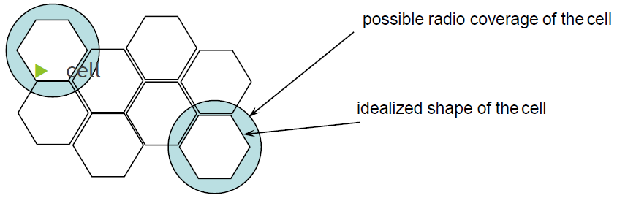

**Typical Cell sizes**

* some cities few hundred meters
* countryside few tens of kilometers

**Advantages**

* more capacity due to frequency reuse
* less transmission power needed
* more robust, tolerate failures
* deals interference, transmission area locally
* Hexagonal shape of cells is idealized (cell overlap, shapes depend on geography)

**Problems**

* fixed network needed for the base stations
* handover (changing from one cell to another) necessary
* interference with other cells